##### A Project report on

##### FACE RECOGNITION APPLICATION FOR MASK DETECTION

###### A Dissertation submitted to JNTU Hyderabad in partial fulfillment of the academic requirements for the award of the degree.

**Bachelor of Technology**

**IN**

**Computer Science and Engineering**

Submitted by

(Student Name) (Roll No)

L. HRITHIK (19H51A0577)

S. JOSPHINE (19H51A0586)

DISHA SAINI (19H51A0590)

Under the esteemed guidance of

**(Dr. P ANJUSHA)**

**(HOD, DEPT. OF CSE- AI/ML)**

**Department of Computer Science and Engineering**

**CMR COLLEGE OF ENGINEERING AND TECHNOLOGY**

(An Autonomous Institution under UGC &JNTUH , Approved by AICTE, Permanently Affiliated to JNTUH, Accredited by NBA.)

KANDLAKOYA, MEDCHAL ROAD, HYDERABAD - 501401.

2019- 2023

**CMR COLLEGE OF ENGINEERING &TECHNOLOGY**

KANDLAKOYA, MEDCHAL ROAD, HYDERABAD – 501401

**DEPARTMENT OF COMPUTER SCIENCE AND ENGINEERING**



#### CERTIFICATE

This is to certify that the Mini Project-1 report entitled **"FACE RECOGNITION APPLICATON FOR MASK DETECTION"** being submitted by L. **Hrithik (19H51A0577), S. Josphine (19H51A0586), Disha Saini (19H51A0590)**in partial fulfillment for the award of **Bachelor of Technology in Computer Science and Engineering** is a record ofbonafide work carried out his/her under my guidance andsupervision.

###### The results embodies in this project report have not been submitted to any other University or Institute for the award of any Degree.

**DR. P. ANJUSHA DR. K.VIJAYAKUMAR**

**H OD OF CSE-AI/ML**

**Professor and HOD**

**Dept.ofCSE Dept. ofCSE**



##### ACKNOWLEDGEMENT

We are highly indebted and grateful to our guide Dr. P. Anjusha, HOD of CSE-AI/MLfor his excellent guidance and constant encouragement throughout for the successful completion of the Project.

We are obliged and grateful to thank Dr. K VIJAYA KUMAR, Head of the Department of Computer Science and Engineering, CMRCET, for his cooperation in all respects.

We would like to thank Major Dr.VA NARAYANA, Principal, for his support in the course of this project work.

We would like to thank Sri Ch. GOPAL REDDY , Secretary& Correspondent of CMRCET, for his cooperation in all respects during the course.

Finally we would like to thank all teaching & non- teaching staff members of the department, for their cooperation and support throughout the duration of our course.

Ultimately we own all our success to our beloved parents, whose vision, love and inspiration has made us to reach out for these glories.



**DECLARATION**

We hereby declare that results embodied in this Report of Project on **“FACE MASK RECOGNITION APPLICATION FOR MASK DETECTION”** are from work carried out by using partial fulfillment of the requirements for the award of B. Tech degree. We have not submitted this report to any other university/institute for the award of any other degree.

**NAME SIGNATURE**

HRITHIK (19H51A0577)

S. JOSHPHINE (19H51A0586)

DISHA SAINI (19H51A0590)



**TABLE OF CONTENTS**

|  |  |  |  |
| --- | --- | --- | --- |
| **CHAPTERS** | | **DESCRIPTION** | **PAGE No** |
|  |  | **Abstract** | 3 |
| **1** |  | **Introduction** | 4 |
|  | 1.1 | Objective | 4 |
| **2** |  | **Existing solutions** | 5 |
| **3** |  | **Proposed System** | 6-12 |
|  | 3.1 | Proposed solution | 6 |
|  | 3.2 | Description | 7 |
|  | 3.3 | Requirements | 8 |
|  | 3.4 | Modules in system | 9 |
|  | 3.5 | How it works | 10-12 |
| **4** |  | **Diagrams** | 13 |
|  | 4.1 | phase Diagram | 13 |
|  |  |  |  |
| **5** |  | **Results and Discussions** | 14-23 |
|  | 5.1 | Advantages | 16 |
|  | 5.2 | Future scope | 17 |
|  | 5.3 | Screenshots of execution | 18-23 |
| **6** |  | **Summary and conclusion** | 24 |
|  | 6.1 | Conclusion | 24 |
|  | 6.2 | References | 24 |

**FIGURES**

|  |  |  |  |
| --- | --- | --- | --- |
| **CHAPTER** | | **NAME** | **PAGE NO** |
| **4** |  |  |  |
|  | 4.1 | DIAGRAM | 12 |
|  |  |  |  |
| **5** |  |  |  |
|  | 5.1 | SCREENSHOT OF EXECUTION | 18 |
|  | 5.2 | SCREENSHOT OF EXECUTION | 19 |
|  | 5.3 | SCREENSHOT OF EXECUTION | 20 |
|  | 5.4 | SCREENSHOT OF EXECUTION | 21 |
|  | 5.5 | SCREENSHOT OF EXECUTION | 22 |
|  | 5.6 | SCREENSHOT OF EXECUTION | 23 |

**ABSTRACT**

* COVID-19 pandemic has rapidly affected our day-to-day life disrupting the world trade and movements. Wearing a protective face mask has become a new normal. Therefore, face mask detection has become a crucial task to help global society.
* People are now required to wear facial protection at all times. However, there have been several reports of people breaking the regulations and without wearing masks.
* This paper presents a simplified approach to achieve this purpose using some basic Machine Learning packages like TensorFlow, MobileNet, Keras and OpenCV.

**1.INTRODUCTION**

* The trend of wearing face masks in public is rising due to the COVID- 19 corona virus epidemic all over the world. Before Covid-19, People used to wear masks to protect their health from air pollution. While other people are self-conscious about their looks, they hide their emotions in the public to hide their faces.
* Here we introduce a facemask detection model that is based on computer vision and deep learning. The proposed model can be integrated with Cameras by allowing the detection of people who are wearing masks not wearing face masks. The model is integration between deep learning and classical machine learning techniques with Open CV, Tensor flow and Keras. We will achieve the highest accuracy and consume the least time in the process of training and detection.

OBJECTIVE:

* The objective of this project is to create an application that identifies the presence of a face mask on human faces in live streaming videos and photographs.

**2.EXISTING SOLUTIONS**

The existing system deals with CNN (convolution neural network) in the face mask detection models, they use clustering, classification, and maxpooling to train the machine on what is what. The CNN trains the machine with the help of dataset, around 20% of the images in dataset are used to train the machine and the remaining 80% is used for testing the results. The face mask detection model empathizes with the problems faced by people around the globe due to COVID-19. This system helps in a small way to stop the pandemic from spreading and festering into our lives further. The Person Identification model or the face recognition model as it is popularly called uses the face recognition library of python to compare images by similarity detection technique.

### Issues in existing system

In these existing systems it was impossible for the machine to know who is not wearing a mask and the real-world application for these existing systems were minimal.

### Drawbacks in existing system

The major limitations of existing schemes are as follows: -

* CNN used in existing system are slow and resource hungry, which makes the training process slow.
* The existing scheme does not detect multiple faces.
* The existing system does not detect faces from all angles.

.

**3. PROPOSED SYSTEM**

## PROPOSED SOLUTION:

* The design process for face mask detection is,the data set for the face masks is loaded into the training script. The data is then pre-processed after. For the training purpose, a Keras/TensorFlow library named MobileNet_V2 is used, this classifier remains a better version for the CNN neural networks as in this the training procedure is relatively faster with a minimal decrease in accuracy. To monitor the training process in this model, the matplotlib library is used to plot a graph.

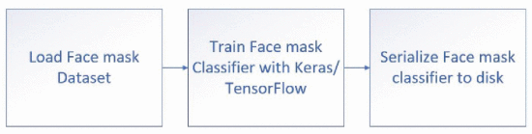

# DESCRIPTION:

The proposed system develops classification and predictive model that can account for accurate classification grouping and prediction of Face masks on the face of a person. The proposed system will focus on enhancing the prediction by increasing its accuracy and detection probability. This is done by using MobileNet_V2. This system also has the ability to identify the persons who are not wearing the masks and send them a mail notification.

**SYSYEM REQUIREMENTS**:

**HARDWARE REQUIREMENTS:**

PROCESSOR : DUAL CORE 2 DUOS RAM : 4GB DD RAM HARD DISK : 250 GB

**SOFTWARE REQUIREMENTS:**

OPERATING SYSTEM : WINDOWS 7/8/10 PLATFORM : VISUAL STUDIO CODE PROGRAMMING LANGUAGE : PYTHON HTML FRONT END : VISUAL STUDIO CODE LIBRARIES : TENSOR FLOW, KERAS, MOBILENET

AND OPEN CV.

**MODULES IN SYSTEM:**

The OpenCV module kicks in to start the video stream, next the program detects faces in the video stream, the face mask classifier is applied to the face ROI to determine “mask” or “no mask”, the results are shown in a highlighted box around the face ROI. If a mask is detected, then the program searches for nearby faces, if a mask is not present, the person identification model starts and tries to identify the person. After the successful run of the person identification model, the mailing system starts and sends an email to the person concerned. This process keeps on iterating unless everyone in the frame is wearing a mask.

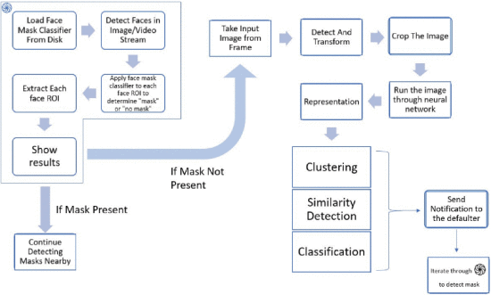

**How it works:**

### Dataset creation

*Mask Detection Model:* The dataset used in this project is made with the help of a script in python which fetches free and open source images from the internet from sites like Kaggle, Google images, etc. These images are put into a folder named without mask. An image of mask was then applied to these images in that dataset to make pictures of people with a mask and these pictures are stored in a folder named with mask. Our dataset structure is as follows:

* dataset
  + with mask [1915 entries]
  + without mask [1918 entries]

*Person Identification Model:* The face recognition module is pretrained for comparing the given data with the data that is being used while execution. The Compare_faces function from the face recognition library of python was used to do this task.

### Data Pre-Processing

The directory for the dataset needs to be specified. A list named categories is made with two entries namely with_mask and without_mask. Then two more lists are made namely Data and labels for snatching the rundown of pictures from the dataset registry, introduce the information and put into its particular class. Then, the labels are binarized and saved in NumPy arrays. Next, the ROI is extracted from the given images to the face part.

### Pre-training Values

INIT_LR is used here to initialize the learning rate. 0.0001 is the initial learning rate, the lower the INIT_LR, the better the results. EPOCHS are the number of passes, the entire training algorithm has completed which will trigger the end of training. Here, 18 EPOCHS are used so that the accuracy for training is high. BS is batch size and it means that the training algorithm will use 32 images at once for training.

The test size and training size is given by the following code snippet, it shows that the testing percentage size is 20%, which means that 20% of the images from the dataset will be used for testing while 80% will be used to prepare the model. The images are selected randomly from the dataset for training and testing purpose.

**Training the model**

Training the model includes augmenting the data, loading the MobileNetV2 classifier, for fine tuning this mode, ImageNet weights are used and built a completely new FC head. The last step involves saving the trained detector model to the disk. The training Procedure involves many steps that are taken from the documentation for the classifier model. Sci-Kit-learn (sklearn) is used for binarizing class marks, dividing our dataset and printing a characterization report. Imutils will assist us with finding the rundown of pictures in our dataset. Fig.3 shows that how data is processed inside the convolutional neural network.

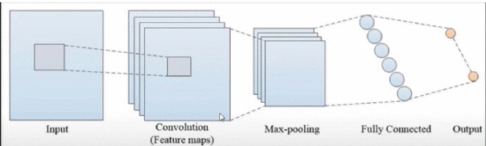

### The Face recognition model

The face recognition module from Python was used for this implementation. Two empty lists are made: -

face _locations=[]

Face_encodings=[]

These empty NumPy arrays are used for comparison with the already specified file locations with images, these images are analyzed for their locations (ROI), their encodings (The ROI coordinates) and their names, which are assigned already. The frames in the real time video streams are compared with already existing data using similarity detection techniques.

.

## 4.DIAGRAM:

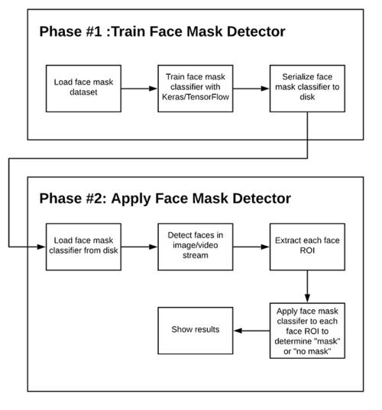

Phases and individual steps for building a COVID-19 face mask detector with computer vision and deep learning using Python, OpenCV, and TensorFlow/Keras.

**5.RESULTS AND DISCUSSIONS**

### Pre-Processed data

The dataset with the extracted ROI is stored exactly as the code that was fed in the script. The face part from the entire image is extracted by the use of Image Net weights, this extracted image is then used to train the AI model.

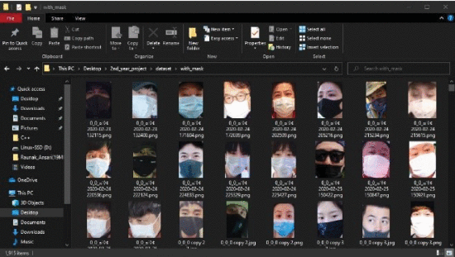

### Training results in face mask detection model

The Graph is plotted to analyze the training data in the dataset and it is plotted using the matplotlib library of python. A graph is designed to show data and value, loss and accuracy as the epochs progress, here the epochs mean the number of passes that the training algorithm has completed. This graph was plotted using matplotlib. Fig. 5 shows the plot that the software plotted which shows the accuracy of the training algorithm. This curve shows that as EPOCHS passed the training accuracy has been constantly above 98% and the data loss has been much high in the initial EPOCHS but has been minimized to 5% and under.

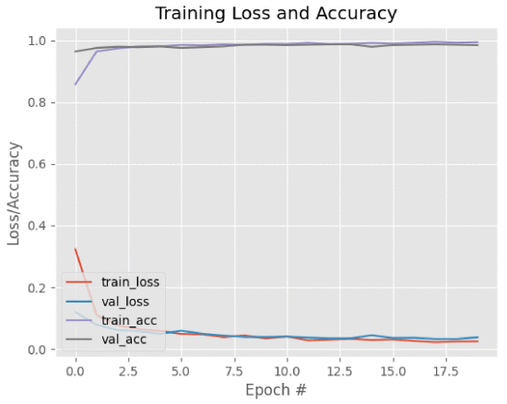

### Detecting in real time video streams

The face mask detector model is loaded into this script, the detector model is then used to make predictions and calculate the probability of a person wearing or not wearing a mask. These predictions are looped in for every frame and for each iteration the detector model is referenced and the values that were trained in the earlier training script are now used. Imutils was used to call the Video stream function which helps us initializing video streams over the network or with the help of local webcams on our personal computers. OpenCV was used to make frames and display data in the frames like the predictions and the probability.

### Working Prototype Images

Figure shows the Face-mask detection model detecting a person who is wearing a mask.

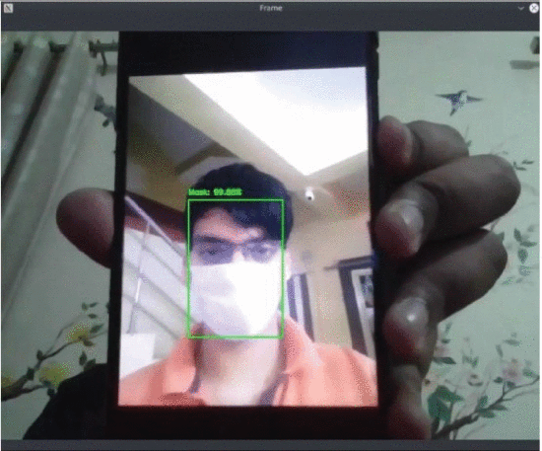

### ADVANTAGES OF PROPOSED SYSTEM

* The accuracy will be more and the time complexity will be less due to the MobileNet algorithm implementation.
* This proposed system uses existing IP cameras of the large institutions to monitor the people, so it is economically feasible as no extra investment is required.
* Proposed system detects multiple faces and face masks from all angles in a small-time frame.

**FUTURE SCOPE:**

The future work is as follows: -

* Perform the classification efficiently
* Using multiple datasets which could attain the optimum prediction.
* Database creation and addition of people in that database who are frequent defaulters
* Improve the overall time complexity of the entire workflow.
* Integrate the Person identification model and face mask detection model into a single detection algorithm.

**Screenshots of Execution:**

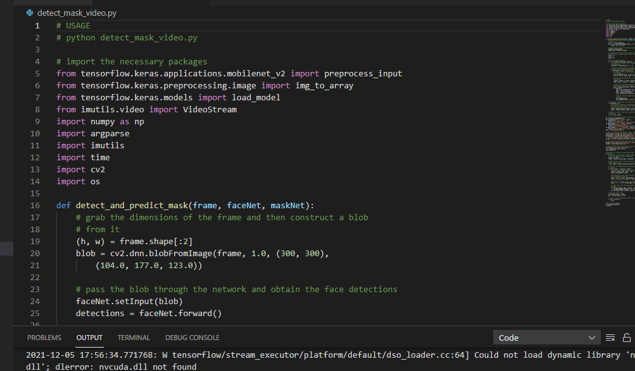

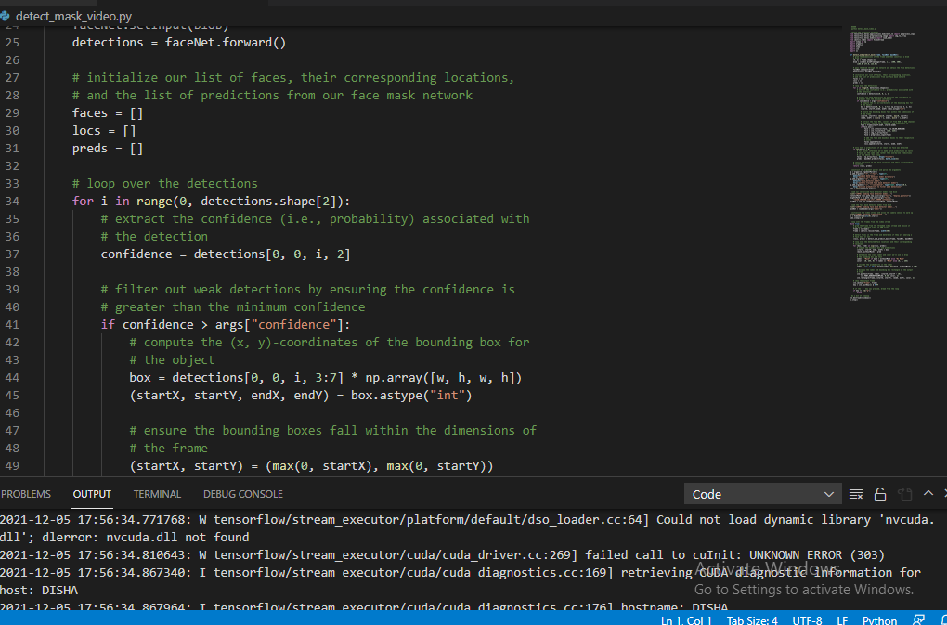

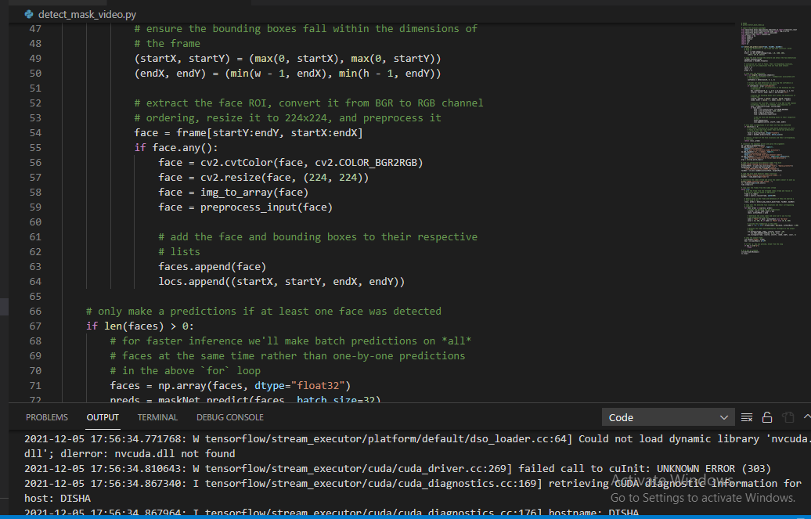

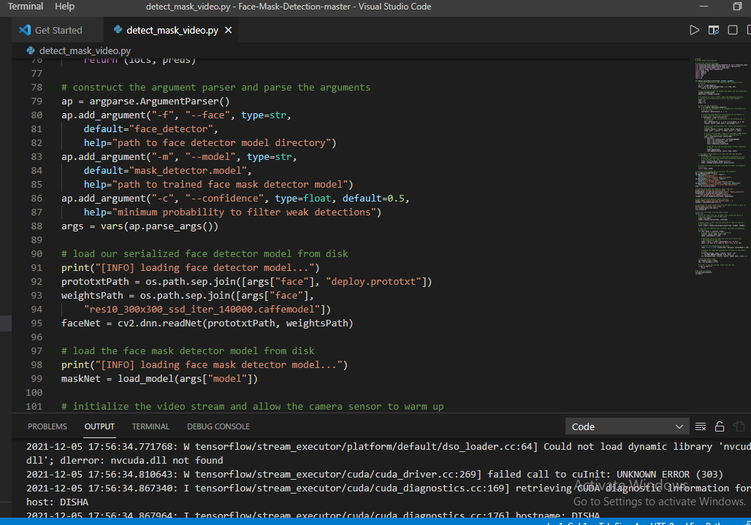

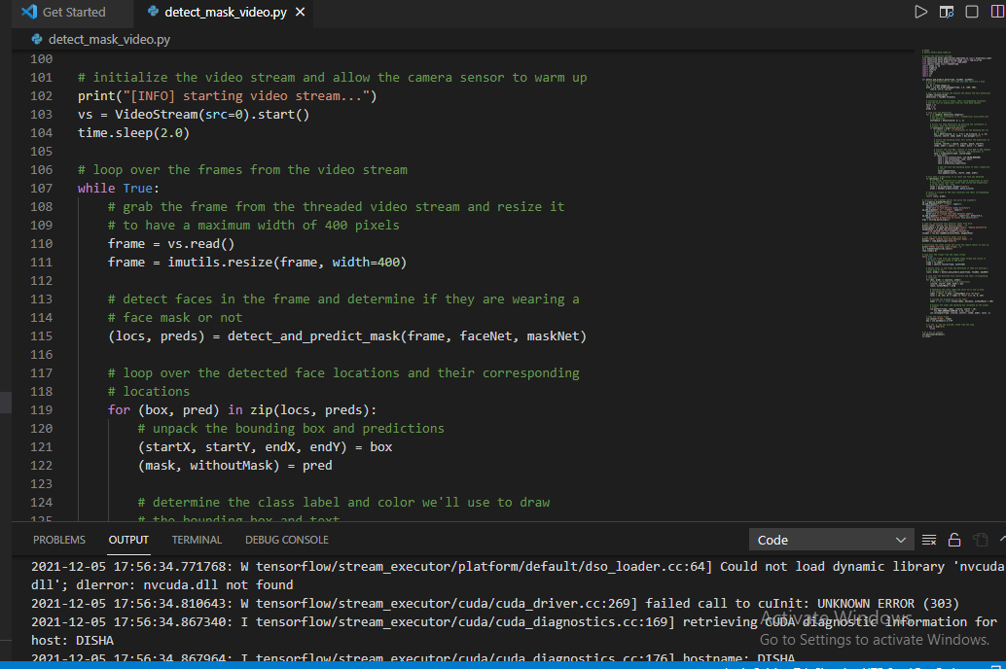

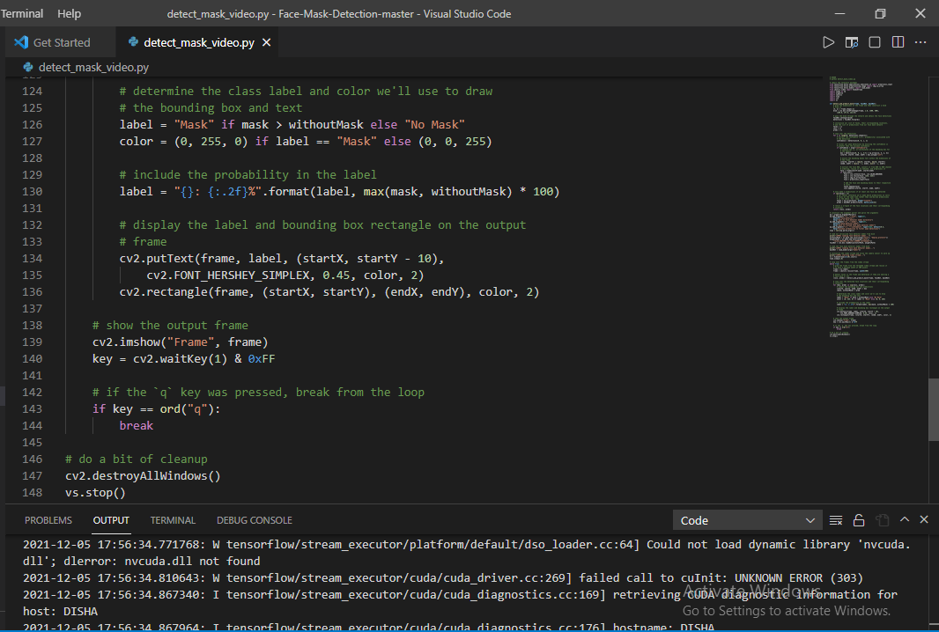

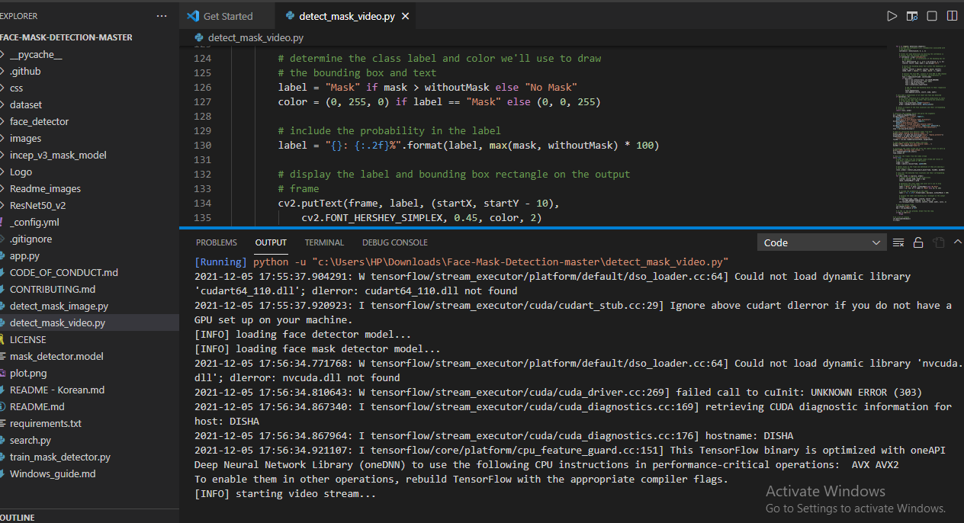

## Screenshot (122).png

## Screenshot (124).png

**CONCLUSION:**

The work proposed in the system focuses on the important challenge faced by the world during the current times due to the ongoing COVID-19 pandemic. The proposed research work has successfully recognized peoples who have wearing masks or not. Also, this research work has successfully detected multiple people without wearing a mask or with a mask in a single frame of video. This third eye technology focuses on the complicated work of detecting multiple people at once to ensure that people stay safe in these troubled times by ensuring that they follow the guidelines which are issued by the government.

## REFERENCES:

* . QIN, D. LI, identifying facemask-wearing condition using image super-resolution with classification network to prevent covid-19 (2020)
* H. Li, Z. Lin, X. Shen, J. Brandt, G. Hua, in Proceedings of the IEEE conference on computer vision and pattern recognition (2015), pp. 5325–5334
* W. Liu, Z. Wang, X. Liu, N. Zeng, Y. Liu, F.E. Alsaadi, A survey of deep neural network architectures and their applications, Neurocomputing 234, 11 (2017)
* Yang xin, Lingshuang Kong, Zhi Liu, Yuling Chen, Yanmiao Li, Hongliang Zhu, et al., "Machine Learning and Deep Learning Methods for Cyber security", IEEE Access, vol. 6, pp. 35365-35381, May 2018.